CLAAP EVIDENCE (2016-17)
SYBA – REGIONAL GEOGRAPHY OF GOA
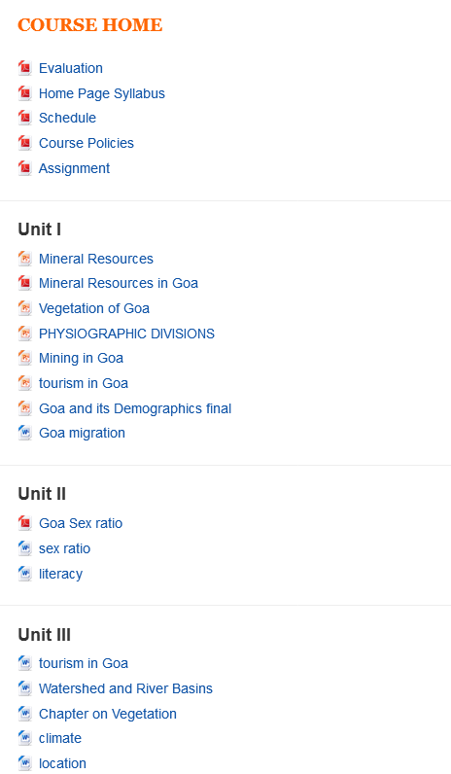

TYBA – GEOGRAPHY OF URBAN SETTLEMENT

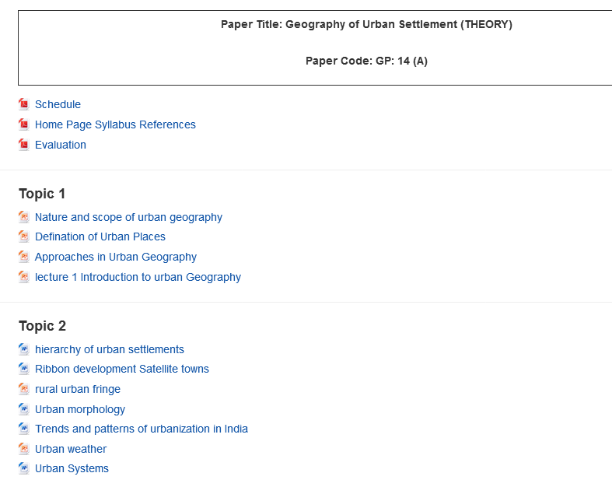

SYBA- REGIONAL GEOGRAPHY OF GOA (PRACTICALS)
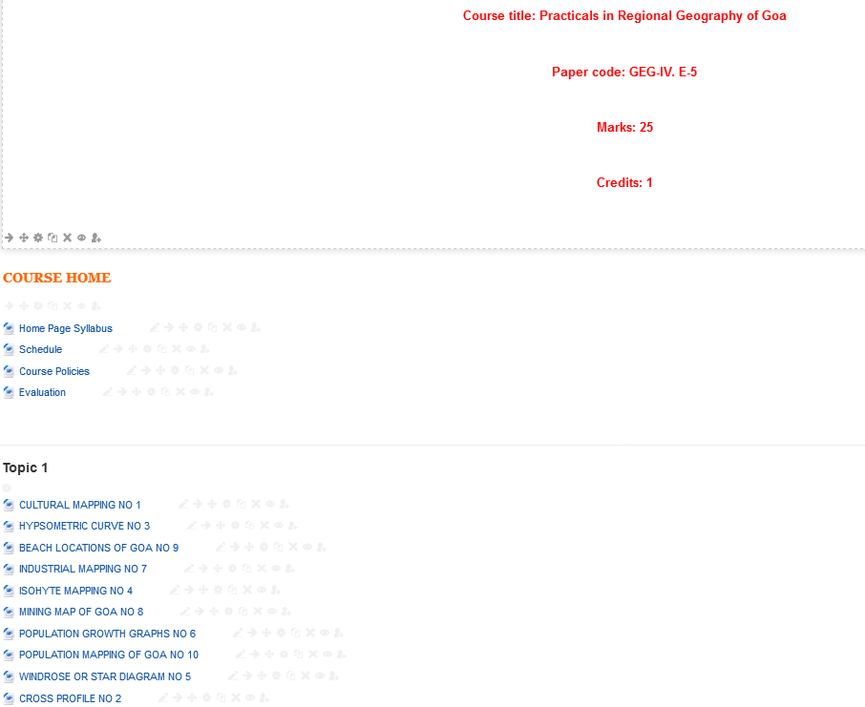

SYBSC- WATERSHED MANAGEMENT
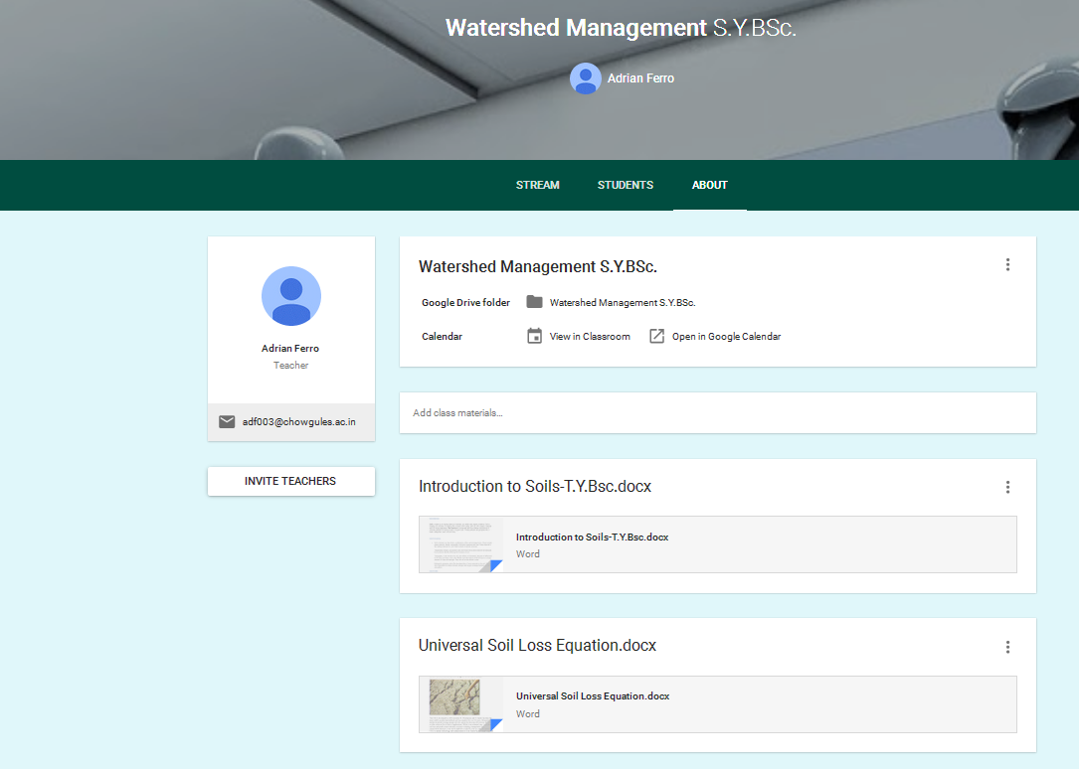

ENVIRONMENTAL STUDIES
